Requisitions
This guide explains the requisition process using Contraceptive Logistics Management Information system.
In this guide, you will learn about:
- Creating New Requisitions
- Viewing Requisitions
EDO (H) uses the Stock Requisitions form to request commodities from CW&S. EDO (H) staff prepares this requisition form on a quarterly basis in consultation with the storekeeper. This form indicates the stock status and consumption during the quarter and indicates the quantity request for each contraceptive being used in respective districts.
The district store users were required to fill out Requisition (CLR-6) based on the previous consumption of that district and submit to the Central Warehouse. However, in Release-2 of cLMIS, Requisition (CLR-6) is auto generated using previous consumption trends for the required quantity of products for the next quarter.
Central Warehouse
Send a Requisition
Issue Stock against each Requisition

District Store

New Requisition
The New Requisition (CLR-6) auto-fills the fields by using previous consumption data of a district in a selected quarter. This form was previously filled by the requester. District users can create requisitions and electronically submit them to the central warehouse. These requisitions will be reviewed by the central warehouse management and stock will be issued as per availability and approved.
To create a new requisition:
- Click Requisition in the side-menu.
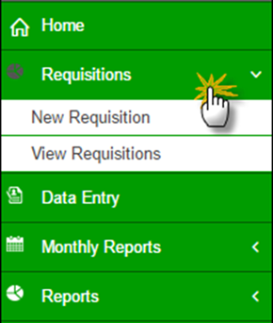

- Specify the Year and Ending Month, and then click Create.
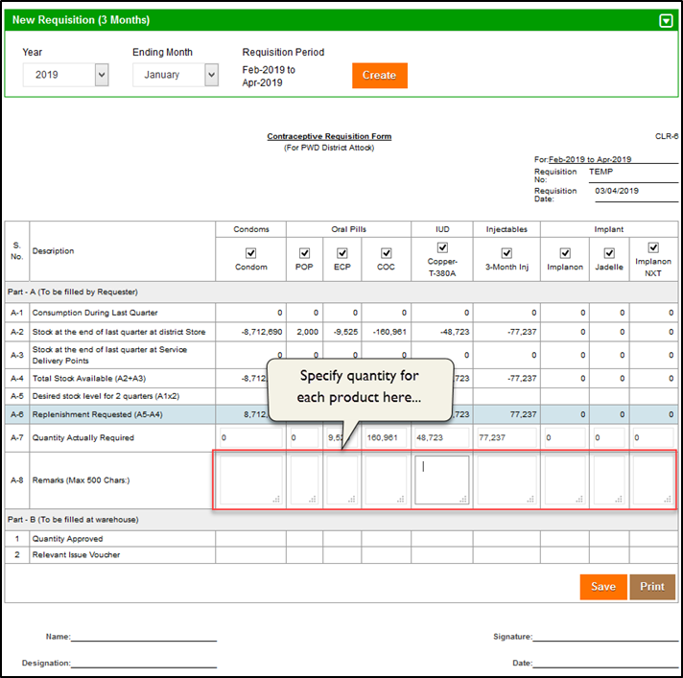
- In A-8, Specify the quantity for each product to be requisitioned.
- Click Save or Print.

View Requisition
District users can also view a comprehensive list of requisition requests placed to the central warehouses. Details of each requisition will also be available for District users to view.
Use the filters to make selections and then click Search.
